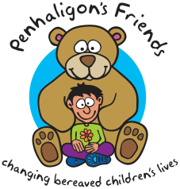
Penhaligon’s Friends
Growing through Grief Conference
Friday 13th March 2020 - Fee: £95

Full Name

Organisation

Address

Phone Number Mobile

Email Address

Invoice Address
(If different)

PO Number
(If applicable)

Dietary
Requirements

Other Needs

Payment Options:
BACS: Sort Code: 30-98-76, Acc No:00322598, Lloyds TSB. Please quote delegate name as reference.
Cheque: Payable to Penhaligon’s Friends and sent to the address below.
Card Payment: Please call the office to pay by card.
Booking conditions: A refund will be given for cancellations less a £30 admin fee. No refunds will be given for cancellations less than 2 weeks before the event. Places are transferrable at the discretion of Penhaligon’s Friends.
We would love to keep in touch to let you know what we’re up to but we will never share your details with third parties. If you would rather not hear from us please tick:

